**Complex Interactive Operation Guide**



# 

## 

## **Introduction**

This guide deals with advanced operation of RAG components within the Interactive framework. After the basic guide covered the three essential components and explained how to use them, this guide expands and presents advanced capabilities in operating the components.

## **Tone**

​​תמונה שמכילה טקסט, גופן, קו, צילום מסך

תוכן בינה מלאכותית גנרטיבית עשוי להיות שגוי., תמונה

### **Component Purpose:**

Determining speaking style, content world, and the purpose of the service it provides.

### **What the Component Receives and Returns:**

Defines the nature of the response for responses not based on documents.

### 

### 

### 

### 

### 

### 

### 

### 

### **Editing Options:**

In places marked with asterisks, we fill in the details relevant to the agent. **It's important to ensure that we fill in the appropriate information in all places marked with asterisks.**

In agents with documents, you can use Tone to encourage targeted questions that will help gather additional information from the user. Once enough details are collected, an answer will be provided from the documents and the agent will stop referring to Tone. When we want an agent to always answer directly from documents and not ask targeted questions or clarify details, we won't use Tone.

### **Mandatory or Not:**

If it's an agent without documents, this component is mandatory. If it's an agent with documents, this component is not mandatory.

## **Guard Rail**

תמונה שמכילה טקסט, גופן, צילום מסך

תוכן בינה מלאכותית גנרטיבית עשוי להיות שגוי., תמונה

### **Component Purpose:**

Filtering irrelevant questions or inappropriate inquiries. In such cases, a predefined message will be returned to the user. This component is checked first if it exists in the Flow.

### **What the Component Receives and Returns:**

Receives user input and checks if it's related to the agent's topic.

### 

### 

### 

### **Editing Options:**

It's recommended to use the existing template and adapt it to the nature of the agent by changing the words marked with asterisks. Additionally, at the end of the prompt, examples for True/False states will appear. These examples will change according to each agent's fields of operation.

If the user's question receives **True**, then it will be sent to Classifier. If the user's question receives **False**, then we get the response from the Guard message.

### **Format:**

Response Format:

User: [Users message]

[true/false]

### **Mandatory or Not:**

This component is not a mandatory component.

## **Special Guard Rail**

This is a situation where we want to adapt the agent's response according to different contexts in which a **False** value is received. That is, instead of using the general response defined in the Guard message field, the answer will be derived from different settings written in the prompt for each of the possible scenarios of a **False** value. In such a situation, when the response is expected to come from the prompt itself, there is no need to fill in the Guard Message field.

## **End of Conversation Message**

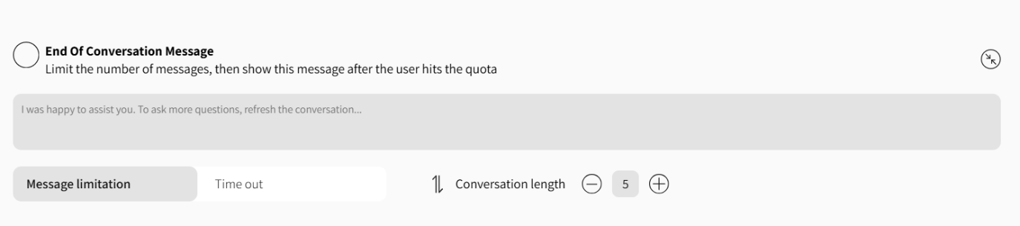

### 

### 

### **Component Purpose:**

To limit the duration of the conversation or the number of messages sent in order to maintain context relevance and prevent deterioration in response quality from the agent in extended or continuous conversations.

### **What the Component Receives and Returns:**

Receives message number limitation or time limitation. After the user reaches the quota, it displays the message we wrote in the text field in this component.

### **Editing Options:**

* Setting message limitation through **Message Limitation** which determines the maximum number of messages in the conversation.
* Setting time limitation through **Time Out** which determines the maximum time period for an active conversation.
* Formulating an end message that will appear automatically when the limitation is realized.

### **Important to Know:**

After displaying the end message, the user will not be able to continue the current conversation and will be required to open a new conversation.

### **Mandatory or Not:**

This component is not a mandatory component.

## 

## 

## 

## 

## **Flow Chart:**

### **Guard - Optional Component**

If a guard prompt exists, the bot will first defer to it. Only if the answer received from this prompt is True will we proceed to the classifier prompt. If False is received, the guard message will be returned.

↓

### **Classifier - Optional Component**

From the classifier prompt, we'll determine what the user wants. If it successfully understands the user's intent, it will proceed to the ranking prompt. If the user's intent is unspecified, it will defer to the tone prompt, if one exists.

↓

**Ranking - Optional Component**

The ranking prompt will retrieve vectors relevant to what the user wants.

↓

### **Response - Mandatory Component**

The response prompt returns the final answer, formulated according to our definitions.

### **Tone - Optional Component**

If the user's intent is unspecified, it will defer to the tone prompt, if one exists. The tone prompt will ask guiding questions to understand what the user wants.